# alamon

BUILDING THE FUTURE NOW

Full-Service Nationwide **Infrastructure** Support

### Communication

5G, Microwave, Line of Sight Surveys, Fiber,

DC Power, Data Centers

### Energy

Battery Energy Storage, EV Charging Stations, Solar Systems

### Enterprise

Structured Cabling, IT Support, IT Asset

Moves, Adds & Changes

### Utility

Wood Pole Inspection, Treatment & Reinforcement, Data Delivery, Fire Shield

315 W. Idaho St. Kalispell, MT 59901

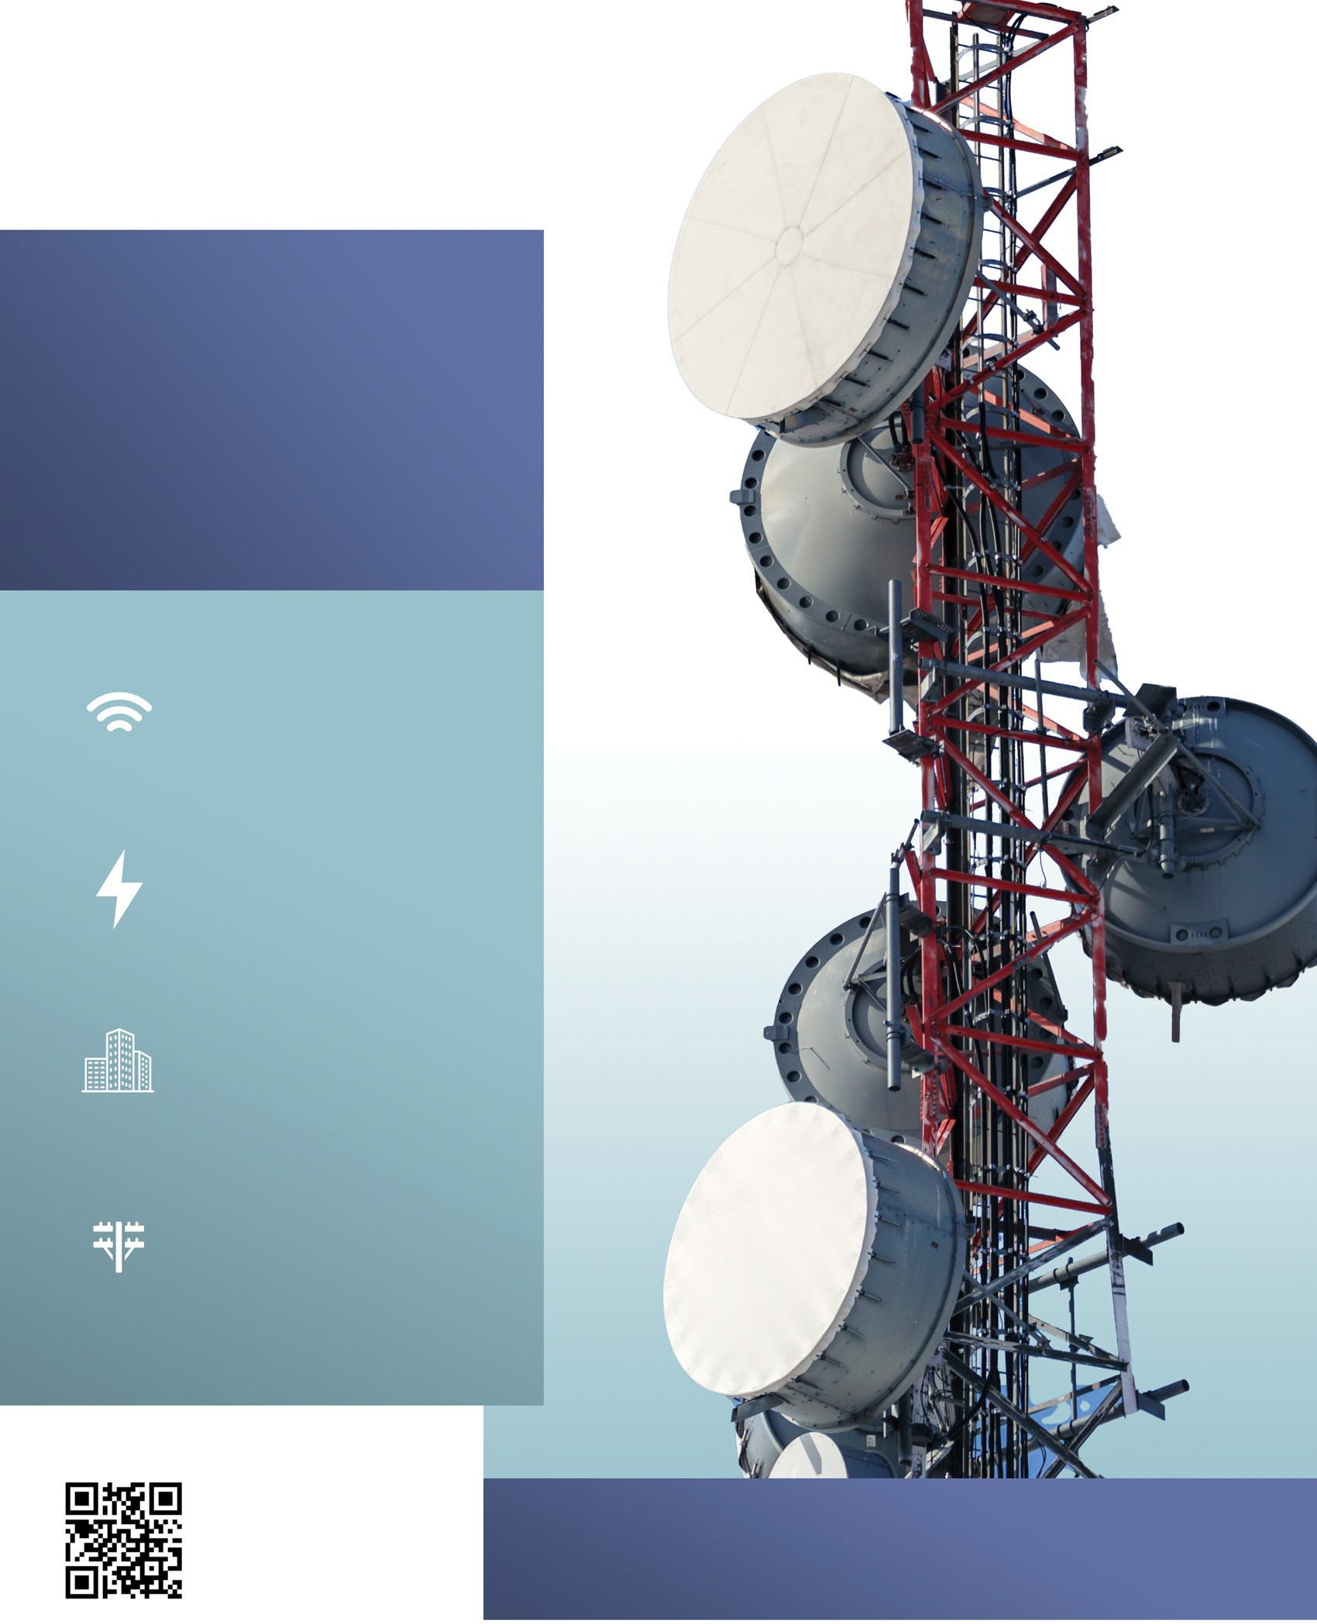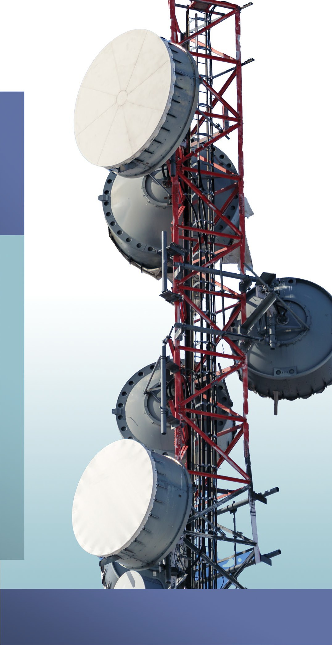

800.252.8838

[www.alamon.com](http://www.alamon.com/)

**SEE OUR FULL LIST OF SERVICES ON PAGE 2**

**Core Capabilities**

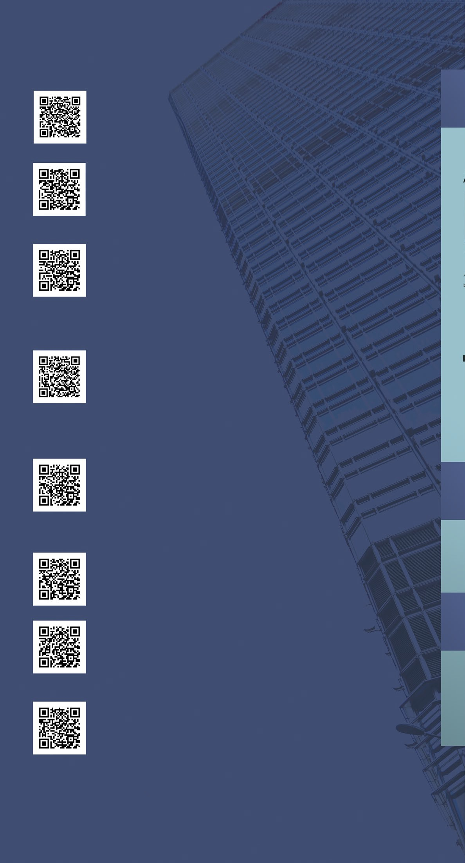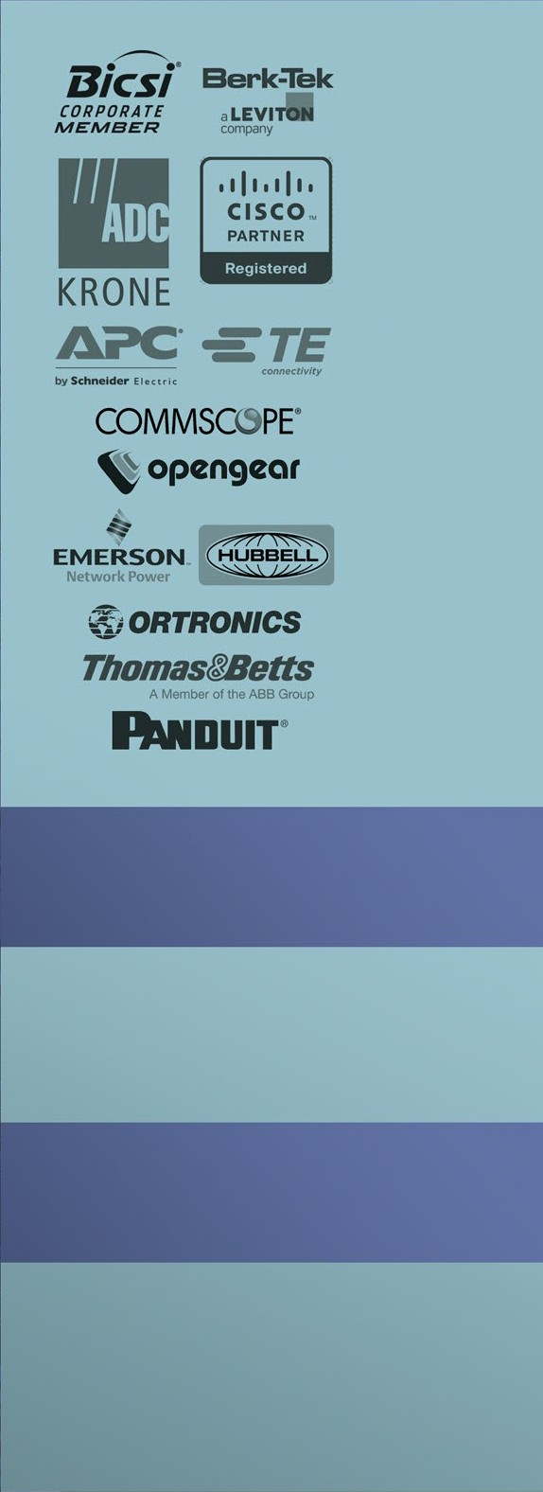

### Civil Construction

* Site Development
* Concrete Installation
* Underground Conduit Installation

### DC Power

* DC Plant Installation, Upgrade & Migration
* VRLA and Flooded Batteries
* Spill Containment Systems
* Field and Detail Engineering

### Energy

* Battery Energy Storage System Installation
* Solar Installation (Ground and Roof Mounted)
* EV Charging Station Installation
* In-House AC and DC Technicians
* Traditional Electrical Services
* Communications Cabling and Alarm Monitoring

### Enterprise

* Structured Cabling
* IT Support
* IT Asset Moves, Adds and Changes
* Secure IT Asset Disposition
* Distributed Antenna Systems
* Sound Masking

### Network

* Testing/Upgrades
* Fiber Characterization
* Site Preconditioning and Physical Installation
* Network and Structured Cabling
* Data Centers

### Outside Plant

* Fiber to the Home Installation
* Aerial and Buried Drop Placement
* Fiber Splicing and Testing

### Utility

* Wood Pole Inspection, Treatment and Reinforcement
* Non-Destructive Wood Pole Inspection
* Fire Mesh Barrier Application
* Data Delivery

### Wireless

* 5G Equipment Installation and Testing
* Microwave Installation and Line of Sight Surveys
* Network Edge Equipment Installation
* Small Cell Deployment
* Maintenance Services/Emergency Response
* Auditing
* Decommissioning

## Certiﬁcations

**Bond Limits**

$30M aggregate (plus)

$15M single (plus)

## NAICS Codes

237130

238210

321114

# alamon

BUILDING THE FUTURE NOW